Saturday,
Sept. 3,
2022

Photo gallery: Seniors get jazzed about performance at La Jolla Community Center
The La Jolla Community Center’s recurring Fourth Friday Jazz Series hosted residents and staff from the Vi at La Jolla Village retirement community on Aug. 26.
The concert, called “Rhythm in a Riff: The Music of Billy Eckstine,” featured saxophonist Christopher Hollyday, pianist Melonie Grinnell and bassist Rob Thorsen.
The next show in the jazz series will feature Thorsen, Holly Hofmann, Mike Wofford and Chuck Redd in “Blame It on the Bossa Nova” on Friday, Sept 23. A reception will begin at 7 p.m., with the concert at 8 p.m. Advance tickets are $22 for Community Center members and $25 for non-members. Admission is $30 at the door.
The Community Center is at 6811 La Jolla Blvd. Learn more at ljcommunitycenter.org/ffjs.
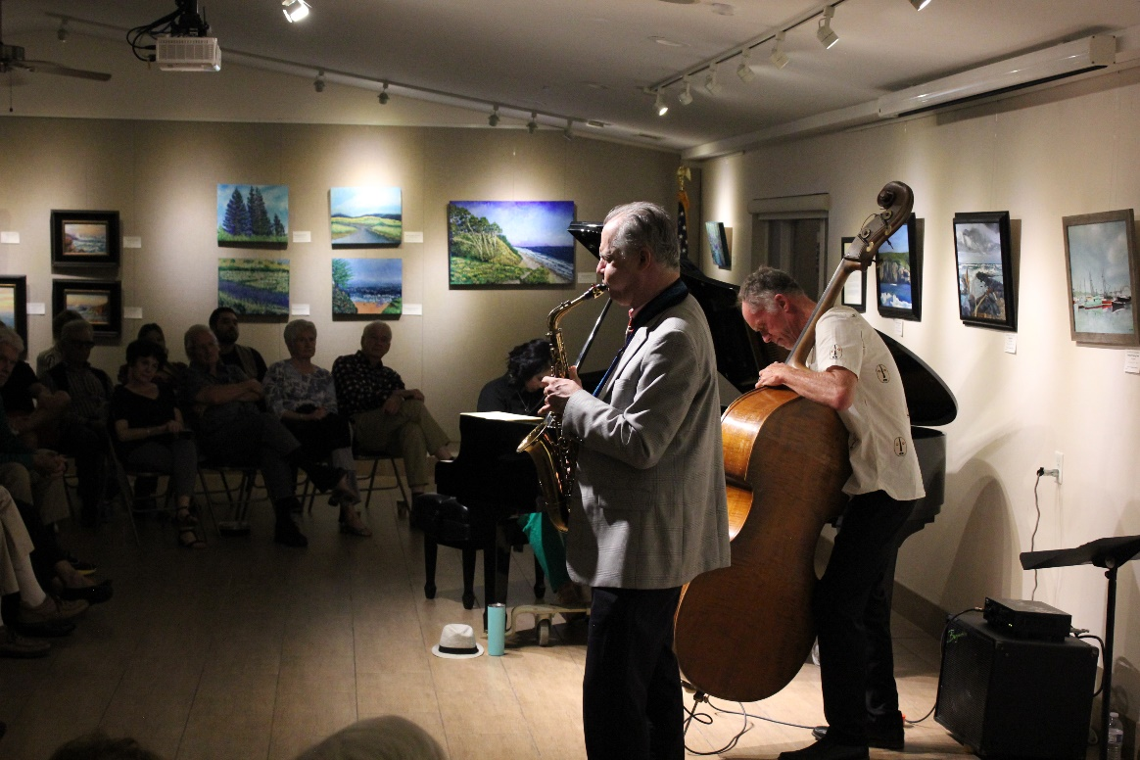
Jazz saxophonist Christopher Hollyday and bassist Rob Thorsen play at the
La Jolla Community Center on Aug. 26. (Courtesy of La Jolla Community Center)

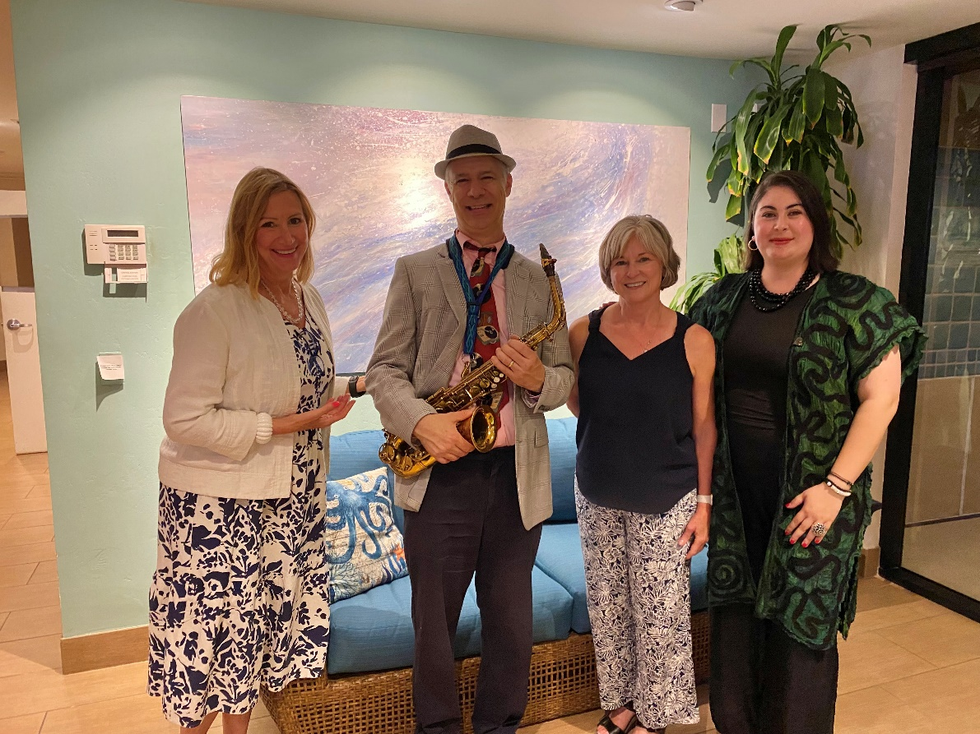
Theresa LaTosh, Community Relations Manager at Vi at La Jolla; Christopher Hollyday;
Mellany Hanson, Lifestyle Director at Vi at La Jolla; and Nancy Walters.

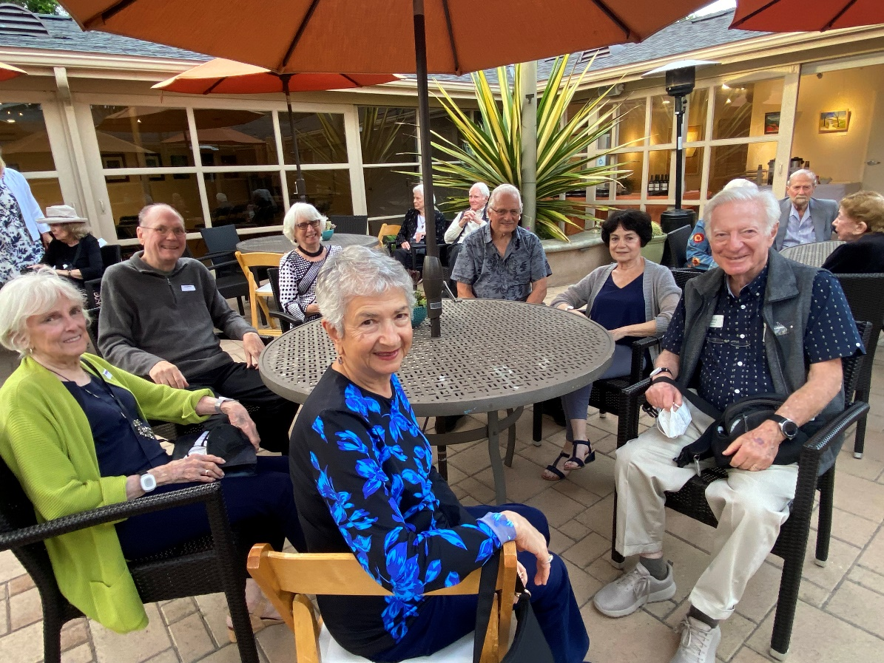
Vi at La Jolla residents enjoying the Fourth Friday Jazz concert. (Courtesy of La Jolla
Community Center.)

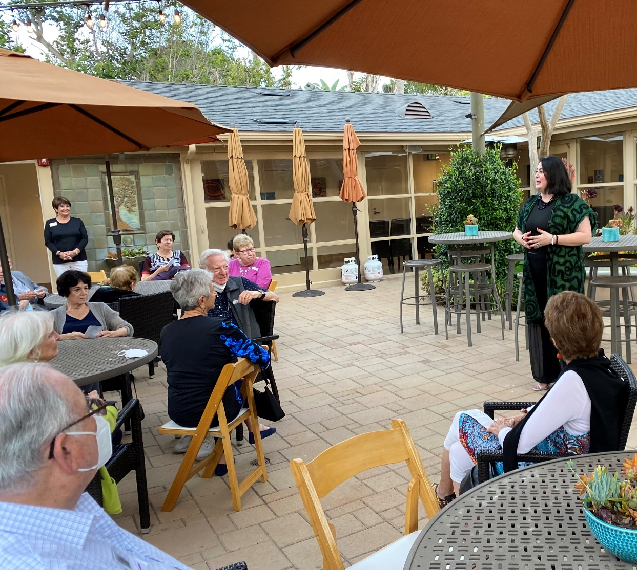
La Jolla Community Center Executive Director Nancy Walters (right) welcomes Vi at La Jolla
Village residents to the center Aug. 26. (Courtesy of La Jolla Community Center)

