6/21/2021

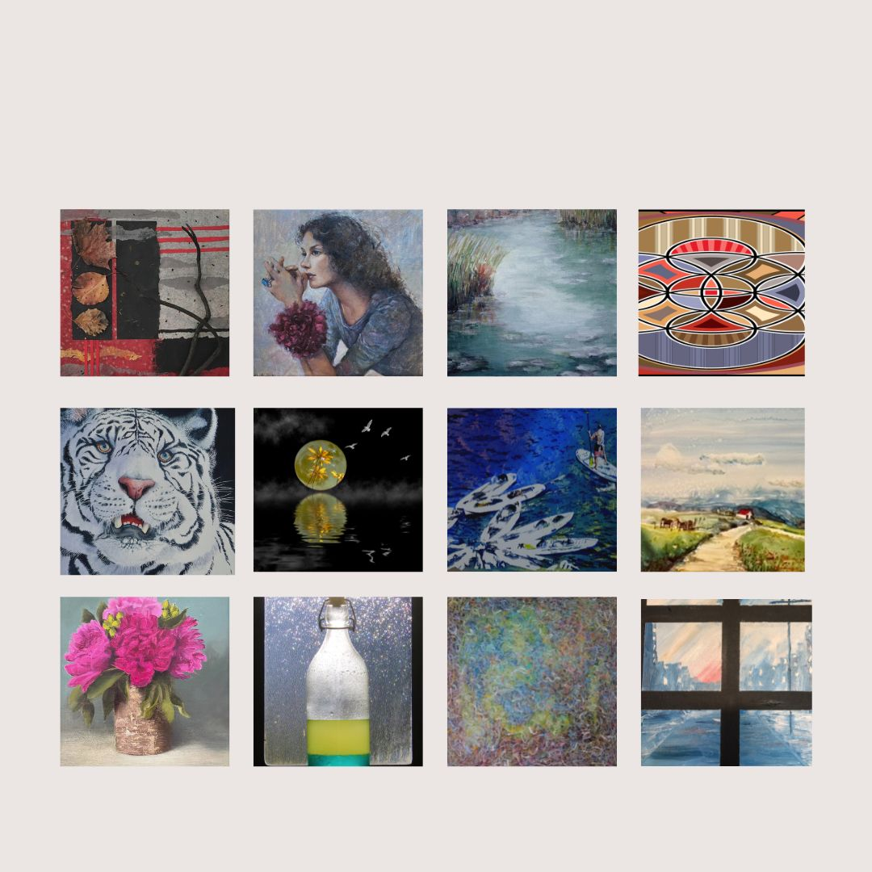

Twelve artists have their work on display at the La Jolla Community Center through Friday, Aug. 5.
(Courtesy of La Jolla Community Center)
The La Jolla Community Center and the La Jolla Art Association present an art exhibition through Friday, Aug. 5, at 6811 La Jolla Blvd. Twelve artists are showing 70 pieces of work in a mixture of media including acrylic, oil, digital and photography. Free. lajollaartassociation.org

